Workplace Stress Survey
We are assessing whether stress is an issue in our workplace
It is important for us to get as much information as possible; make sure you have your say by completing the survey. It provides anonymous feedback and is a quick and easy way to determine the extent to which work-related stress is a problem within your organisation.
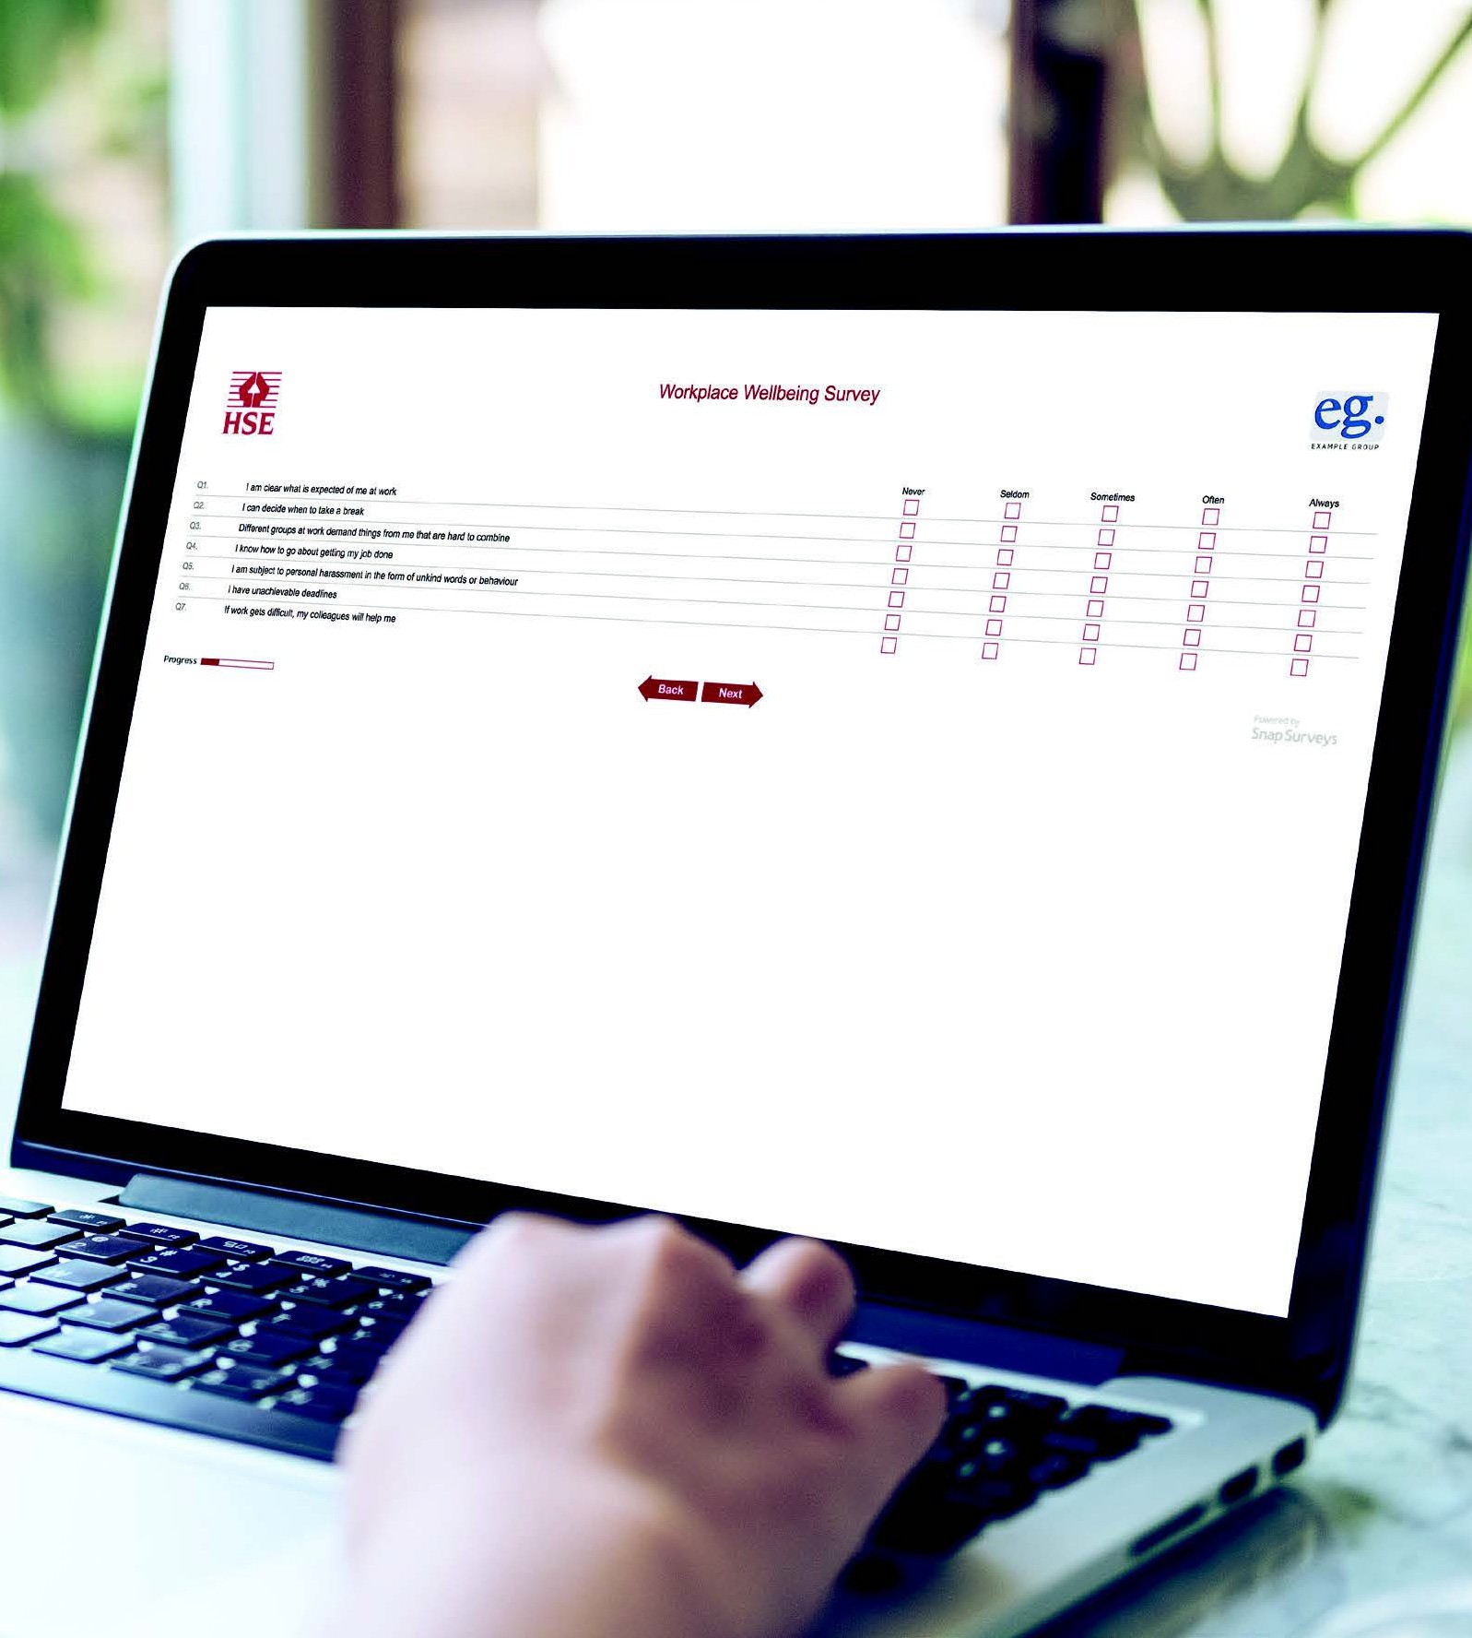
If someone is having problems, getting help early will limit the damage it can cause.

